Exercise 3 Predict 420 Summer 2017 Section 56

Zeeshan Latifi

1. sqlite3 command-window shows only one table before running the Ipython Notebook script

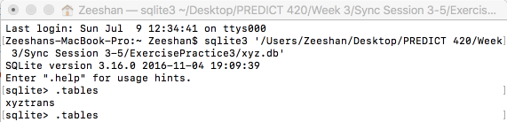

1. First Run for the Ipython Notebook script with no error

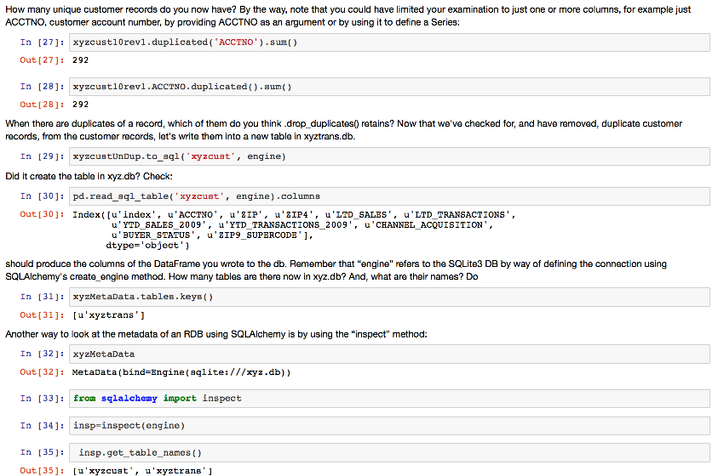

1. sqlite3 command-windows shows two tables after you run the Ipython Notebook script

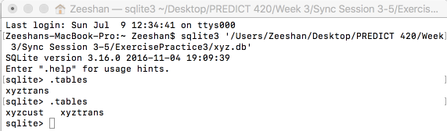

1. Second Run for the Ipython Notebook script that shows error

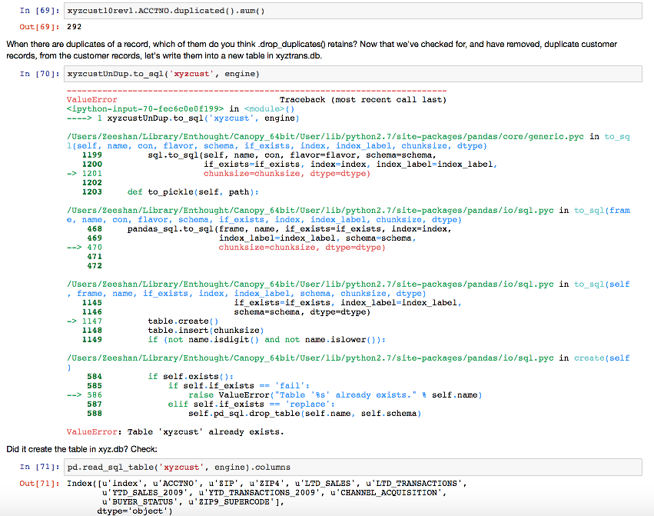

1. sqlite3 command-window shows drop table for xyzcust

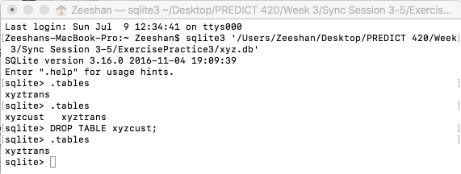

1. Third Run for the Ipython Notebook script that shows NO error

